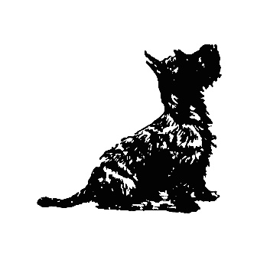
The Black Dog Deli Yoxford

Breakfast - 11am
Filo & Twine Sourdough Toast, Local Butter & Jam 4
Black Dog Fruit & Nut Granola, Greek Yoghurt, Berry Compote & Dark Chocolate Shavings 6.5
Avocado on Sourdough Toast, Poached Hens Egg 8.5
+ Pinney’s Smoked Salmon 2.5 | + Streaky Bacon 2
Dry Cured Bramfield Streaky Bacon Sandwich & Bloody Mary Ketchup 6.5 (available all day)
Small Plates – From 11am
Greek Marinaded Olives 4.5
Labneh, Courgette, Lime, Pomegranate, Coriander & Chilli with Filo & Twine Sourdough Crostini 7.5
Hummus, Toasted Chickpeas, Roasted Piquillo Peppers with Filo & Twine Sourdough Crostini 7.5
Pinney’s Smoked Salmon, Sour Cream, Caper Berries, Lemon & Dill with Toasted Filo & Twine Soda Bread 9
Black Dog Bruschetta, Marinaded Tomatoes, Vegan Pesto & Rocket on Toasted Sourdough 7.5
+ Burrata 4
Melts
Cubano - Pastrami, Smoked Bramfield Ham, Emmental, Dill Pickles & Honey Mustard Mayo 8.5
Italiano – Pesto, Mozzarella, Chilli Jam & Basil 8
East Coast - Bramfield Smoked Ham & Cheddar Toastie 7.5
Salad Bowls
Small – choose one from our freshly prepared salads 5
Salad Meze Bowl – A Main Course combination of all our daily salads, served with Hummus & Sourdough 12.5
Baron Bigod Sharing Board
Baked Baron Bigod Brie, Truffle Honey, Toasted Sourdough Crostini, Lambs Leaf 18

